**LAB 2 - HTML TAGS & ATTRIBUTES**

**SOURCE CODE:**

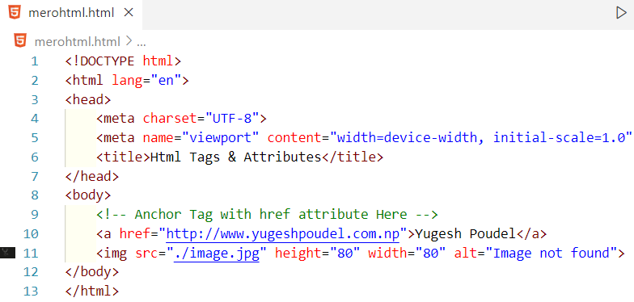

**OUTPUT:**

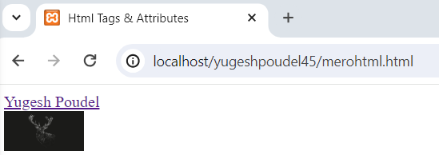

**LAB 3 – BLOCK & INLINE ELEMENTS**

**SOURCE CODE:**

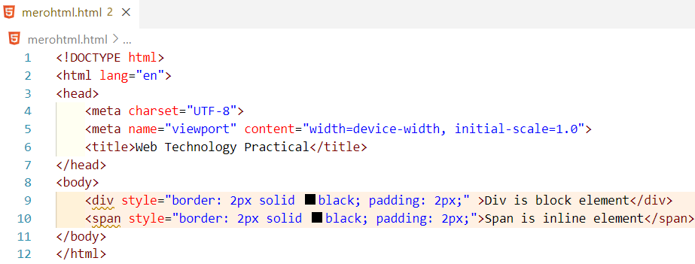

**OUTPUT:**

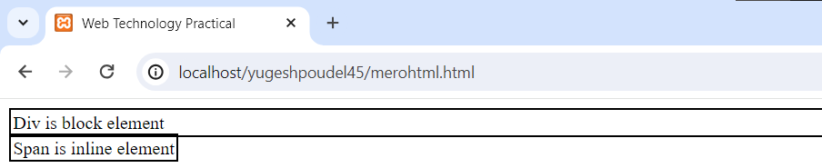

**LAB 4 – FORMATTING TAGS**

**SOURCE CODE:**

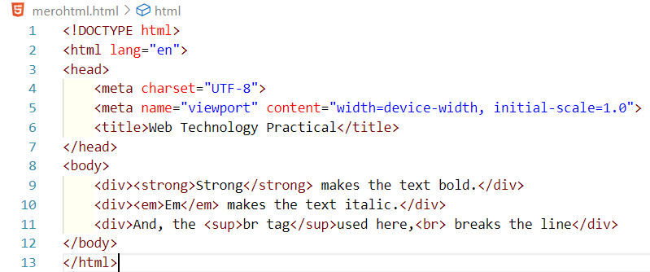

**OUTPUT:**

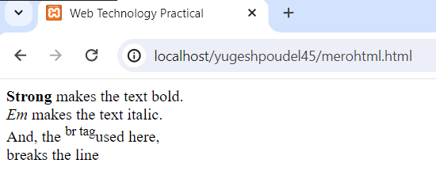

**LAB 5 – ANCHOR TAG**

**SOURCE CODE:**

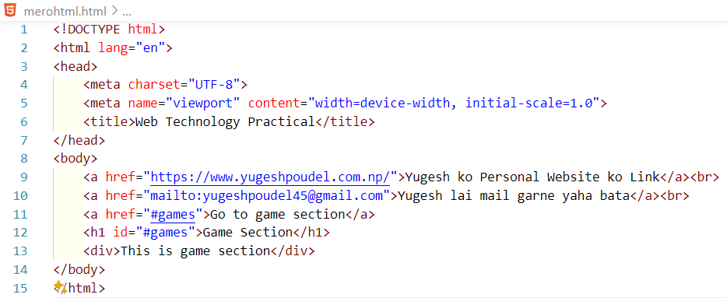

**OUTPUT**

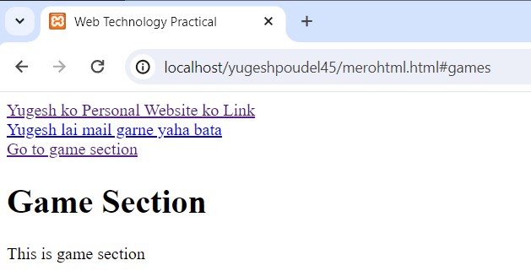

**LAB 6 - IMG TAG**

**SOURCE CODE:**

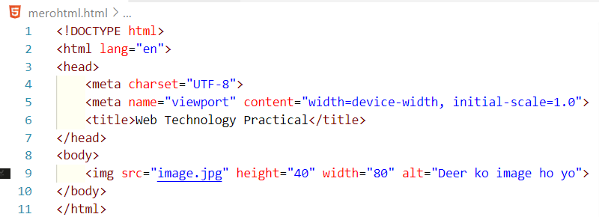

**OUTPUT:**

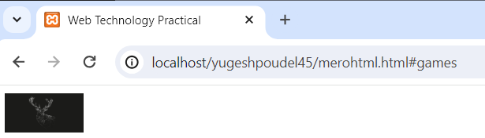

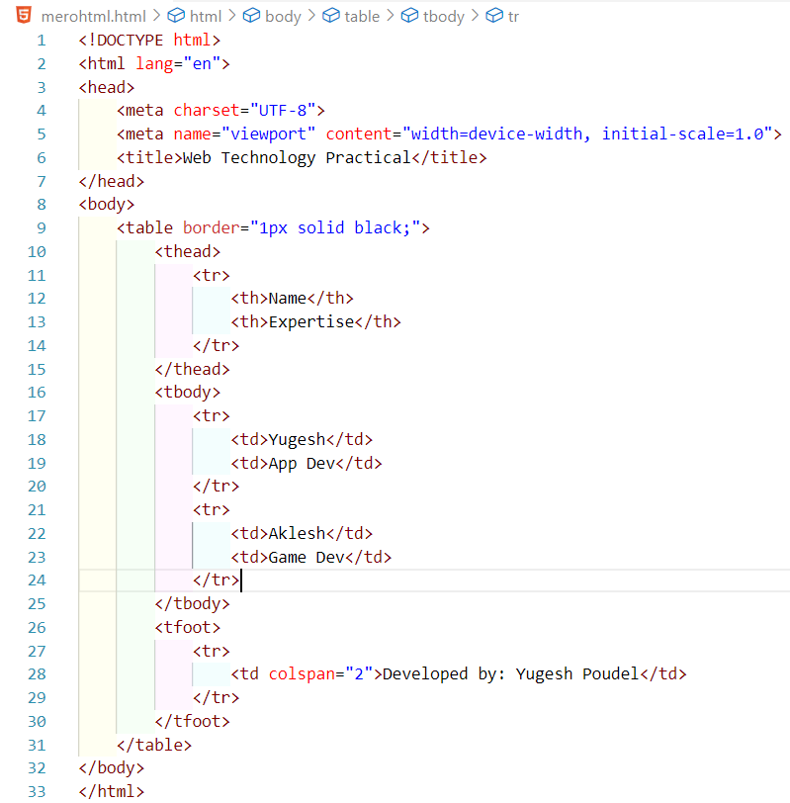**LAB 7: HTML TABLES**

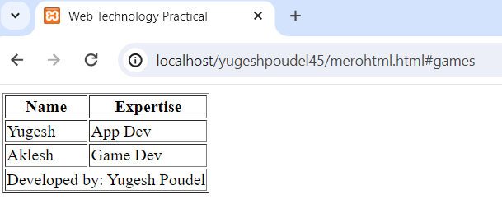

**LAB 8: EVENT ATTRIBUTE**

**SOURCE CODE:**

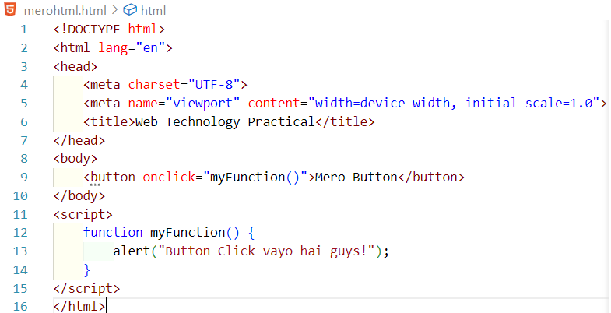

**OUTPUT:**

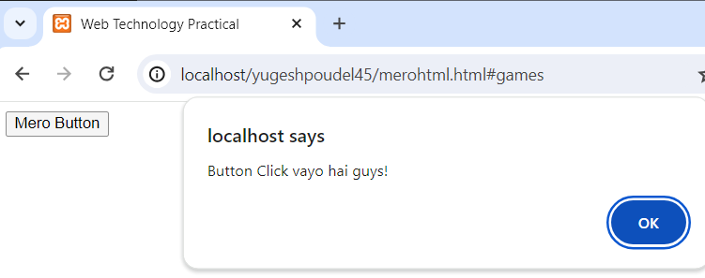

**LAB 9: LOGIN FORM WITH HTTP POST METHOD**

**SOURCE CODE:**

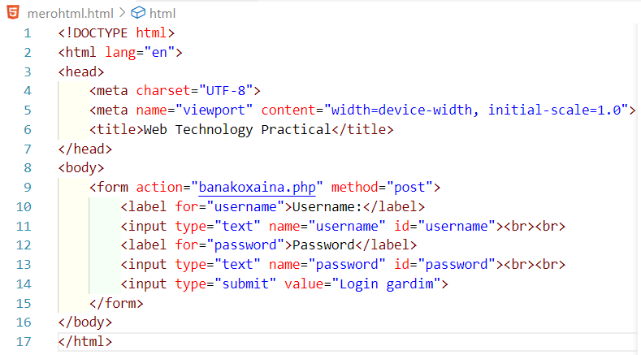

**OUTPUT:**

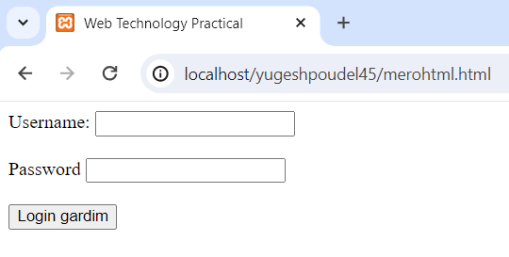

**LAB 10: FORM WITH RADIO BUTTONS & CHECKBOXS**

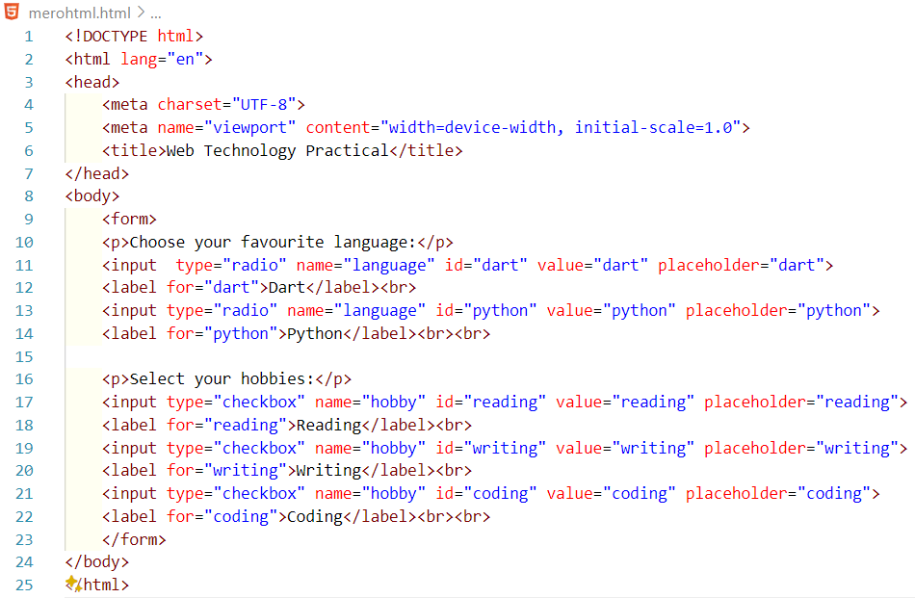

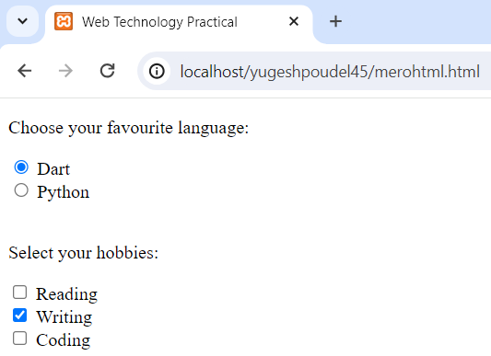

**LAB 11 - FILE UPLOAD FORM**

**SOURCE CODE:**

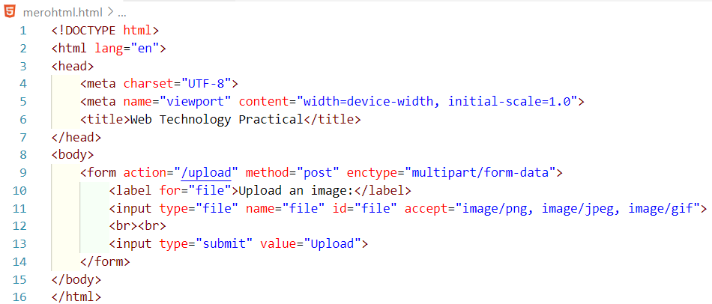

**OUTPUT:**

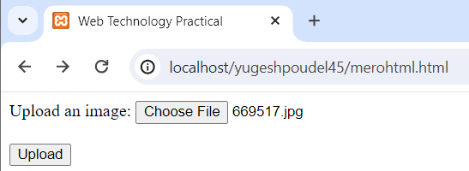

**LAB 12 - ID AND CLASS ATTRIBUTES**

**SOURCE CODE:**

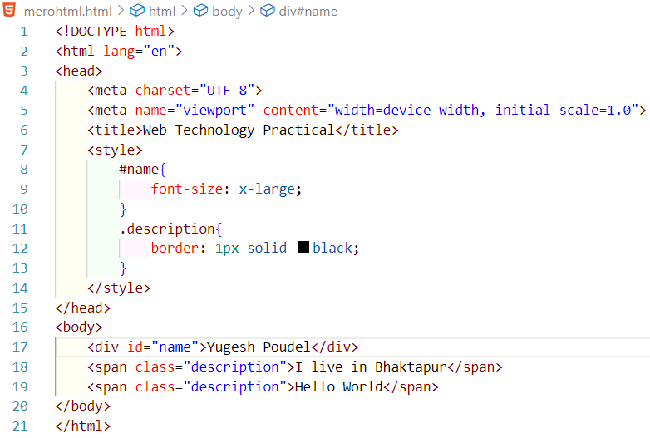

**OUTPUT:**

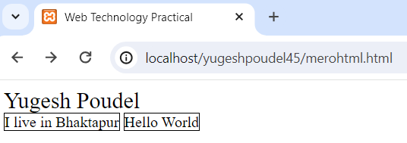

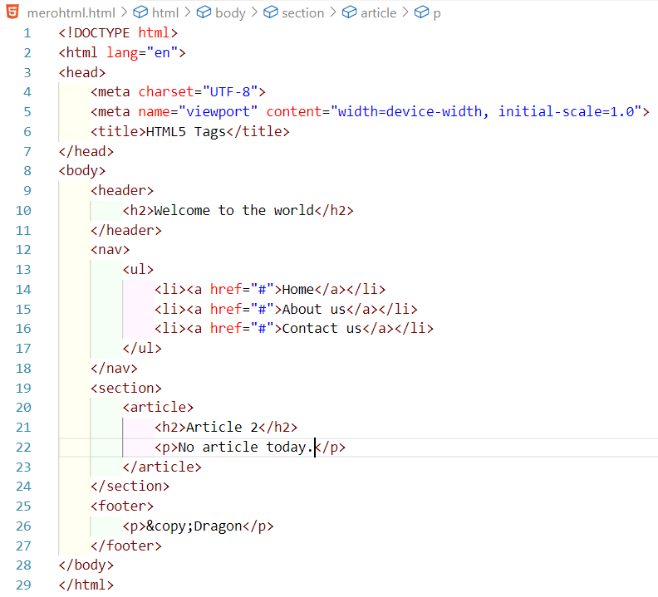**LAB 13 - HTML5 TAGS**

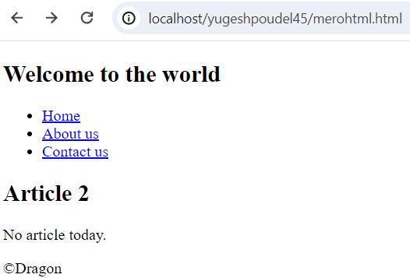

**LAB 14 – TPYES OF CSS**

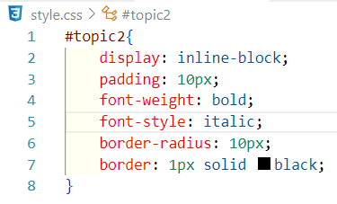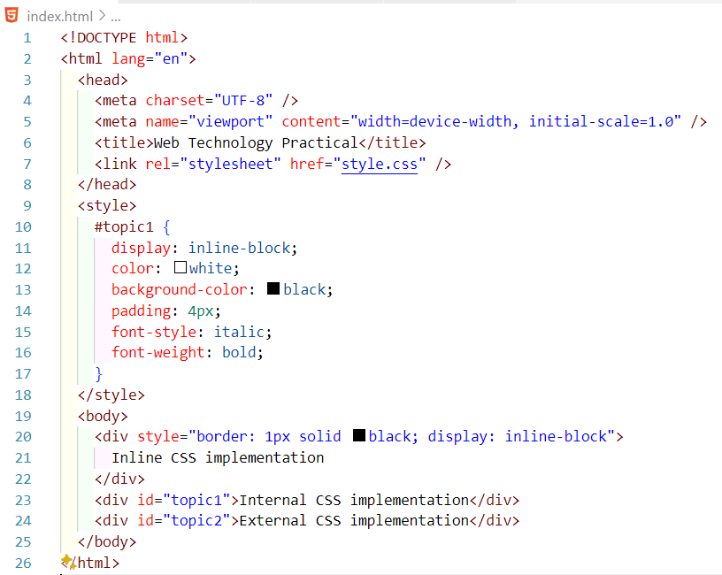

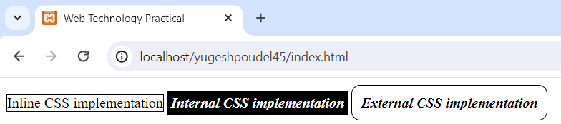**OUTPUT**

**LAB 15: GROUP SELECTOR**

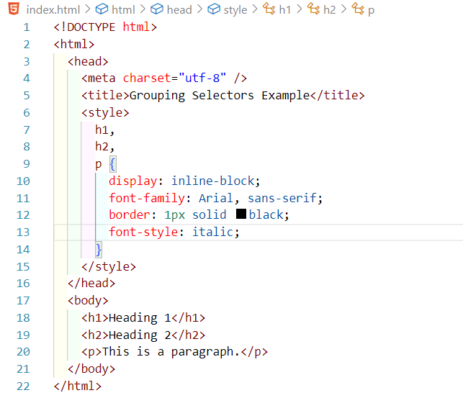

**OUTPUT:**

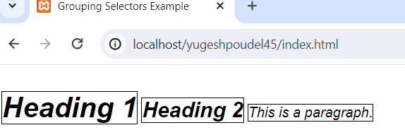

**LAB 16: PSEUDO CLASS**

**SOURCE CODE:**

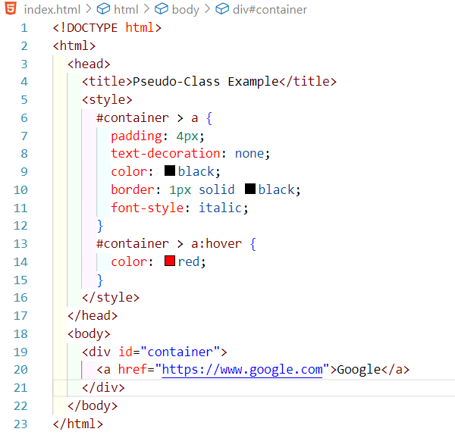

**OUTPUT:**

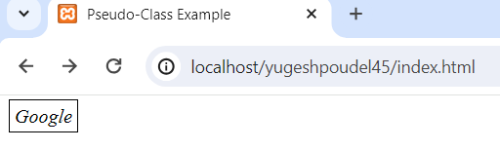

**LAB 17: BACKGROUND IMAGE IN A DIV ELEMENT WITH BORDERS**

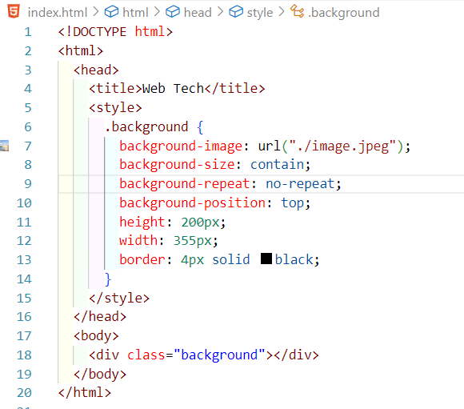

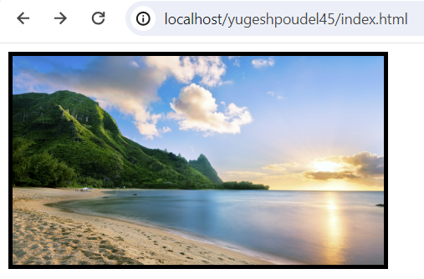

**LAB 18: PADDING & MARGIN**

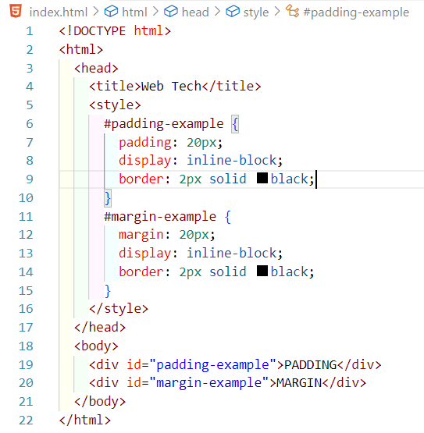

**OUTPUT:**

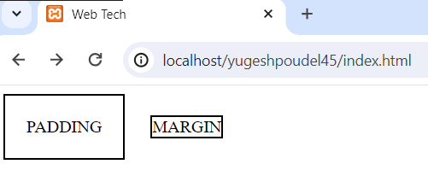

**LAB 19: LIST OF BOXES WITH FLOATING CSS PROPERTY**

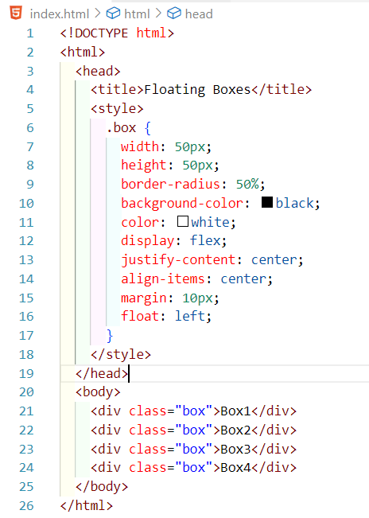

**OUTPUT:**

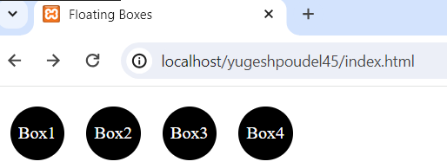

**LAB 20: BOX WITH BOX SHADOW**

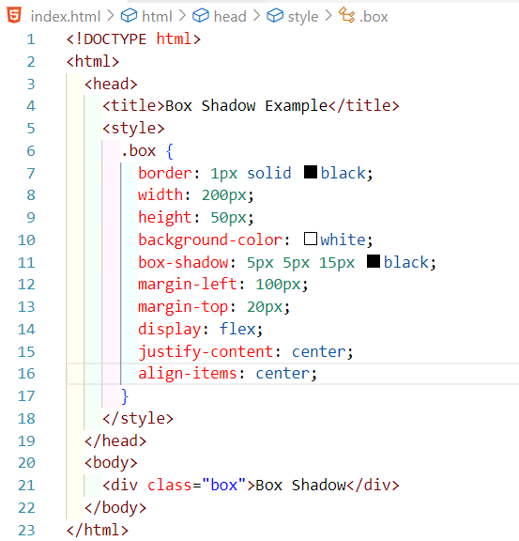

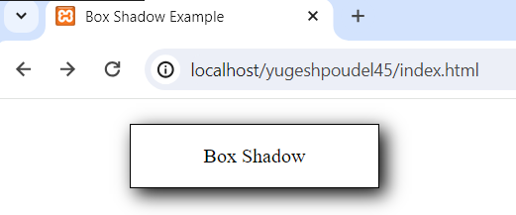

**LAB 21: CSS ANIMATION**

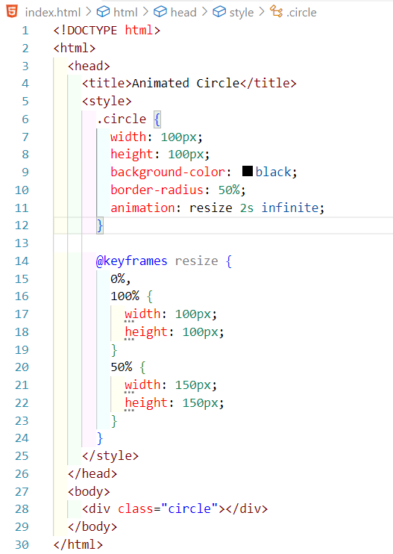

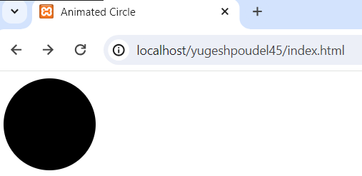

**LAB 22: RESPONSIVENESS WITH MEDIA QUERIES**

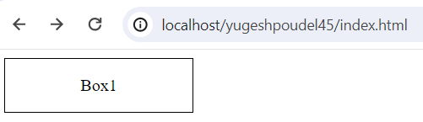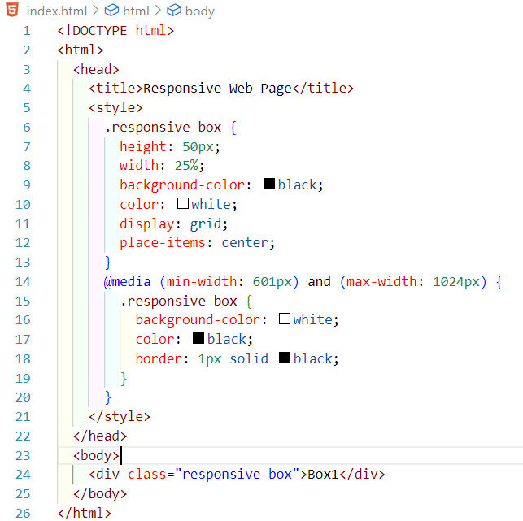

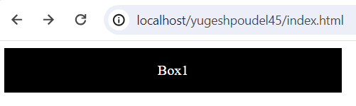

**LAB 23: WEB PAGE LAYOUT WITH BOOTSTRAP GRID SYSTEM**

**SOURCE CODE:**

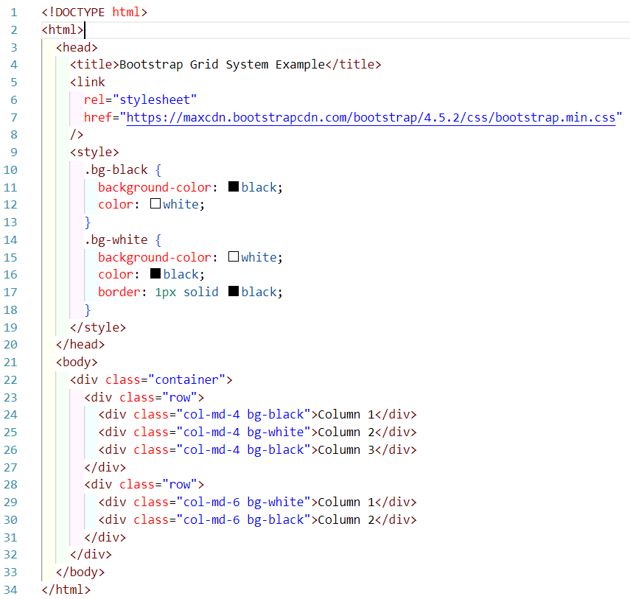

**OUTPUT:**

